**SPRINT – 1**

|  |  |
| --- | --- |
| DATE | 15 NOVEMBER 2022 |
| TEAM ID | PNT2022TMID24781 |
| PROJECT NAME | SMART SOLUTION FOR RAILWAYS |

**PROCEDURE:**

**Step1**: Develop node red application

**Step2**: Install the required nodes from manage palette option

**Step3**: Connect the node flow

**Step4**: Deploy the flow

**WEB APPLICATION :**

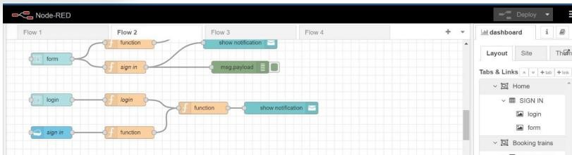

**NODES TO BOOK TRAIN:**

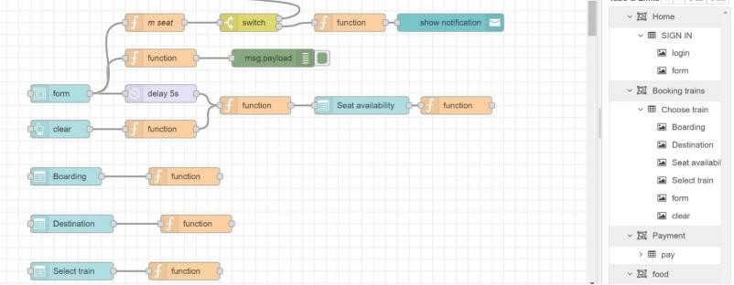

**FUNCTION NODE COMMAND TO INDICATE THE AVAILABLE SEATS**:

var a=global.get('a') var s= []

for(let i=0;i<a.length==0;i++){ s.push(a[i]) } if(s.length==0){

msg.options=[{"No seats available":0}]

} else{ msg.options= s

} msg.payload= s return msg;

**FUNCTION NODE COMMAND TO CHOOSE THE AVAILABLE SEATS:**

var s=global.get('s') var a=global.get('a') function reg(x){ for(let i=0;i<a.length;i++){ if(a[i]==x){

a.splice(i,1)

}

} } if(s==1){ global.set('s1',s) reg(s) } else if(s==2){ global.set('s2',s) reg(s) } else if(s==3){ global.set('s3',s) reg(s) } else if(s==4){ global.set('s4',s) reg(s)

}

else if(s==4){ global.set('s4',s) reg(s) } return msg;

**FUNCTION NODE COMMAND TO STORE DATA IN DATABASE:**

var m=global.get('m') var d=new Date();

var utc=d.getTime()+(d.getTimezoneOffset()*60000); var offset=5.5;

newDate=new Date(utc+(3600000*offset)); var n=newDate.toISOString() var date=n.slice(0,10) var time=n.slice(11,19) var d1=date+','+time msg.payload={

"_id":d1,

"Name":m.Name,

"Age":m.Age,

"Mobile":m.Num,

"boarding":global.get('b'),

"destination":global.get('d'),

"Seat":global.get('s')

} return msg;

**FORM DETAILS:**

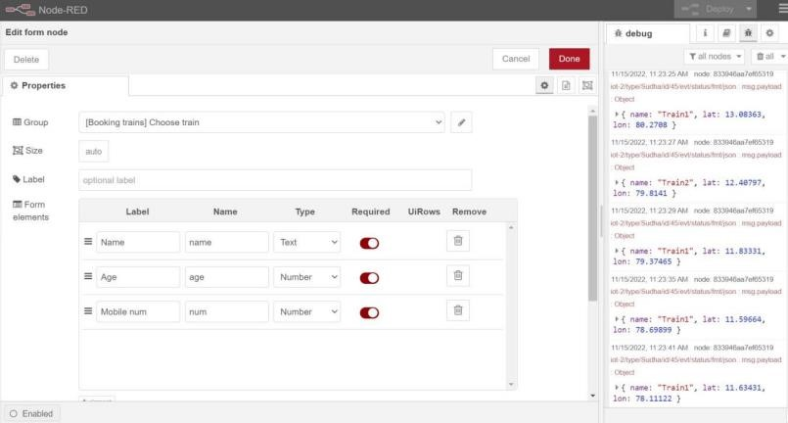

**SEAT DROPDOWN BOX:**

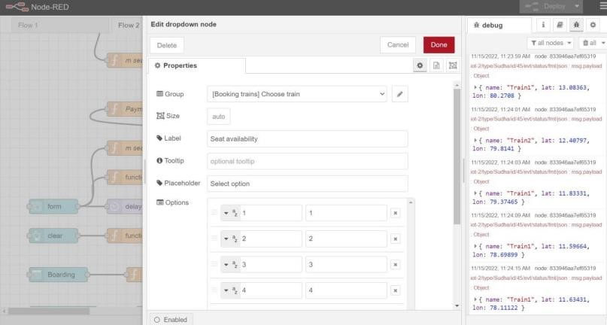

**WEBPAGE FOR TRAIN BOOKING:**

**STEP – 1:**

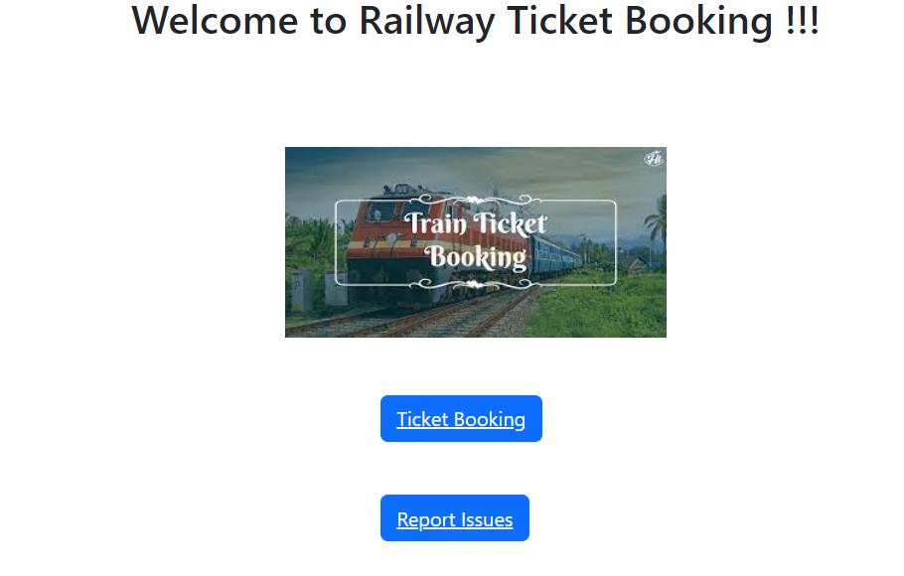

**STEP – 2:**

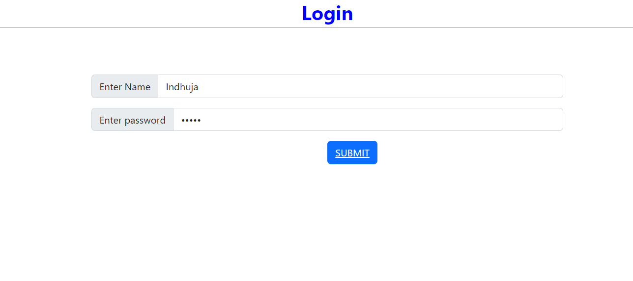

**STEP -3:**

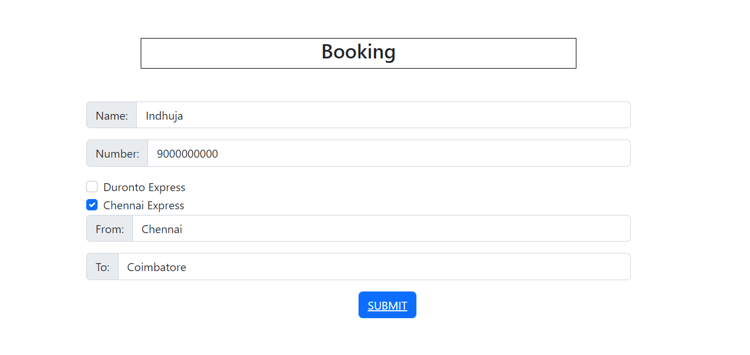

**STEP – 4:**

